## Azure Databricks Assignment

**Name: Vikas Reddy Gorantla**

**Date: 28-11-2024**

## Practice of Loading Data:-

**1. Load and Display Loan Table Data**

# data =spark.read.table("samples.nyctaxi.trips") datatable =spark.read.table("hive_metastore.default.loan") datatable.display()

**2.**

**Create RDDs and Load Delta Tables**

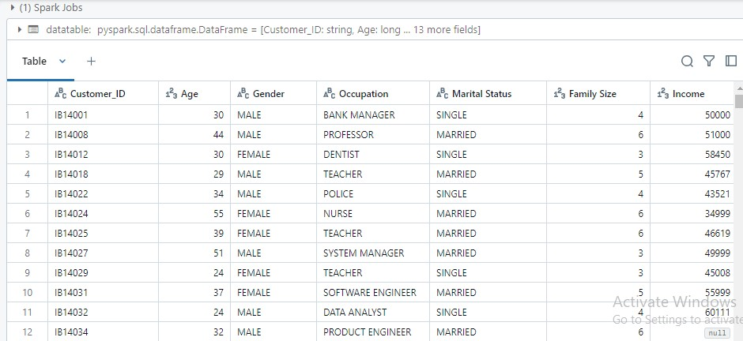

# to create rdds and dataframe from pyspark import SparkContext from pyspark.sql import SparkSession # Initialize SparkContext and SparkSession sc = SparkContext.getOrCreate() spark = SparkSession.builder.appName('pyspark first program').getOrCreate()

data = spark.read.format("delta").load("dbfs:/databricks-datasets/nyctaxi-withzipcodes/subsampled") datatable = spark.read.format("delta").load("dbfs:/user/hive/warehouse/loan") data.display() datatable.display()

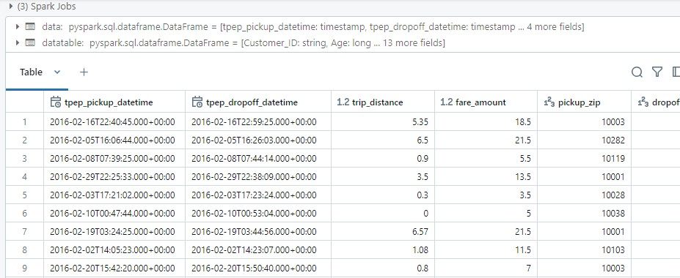

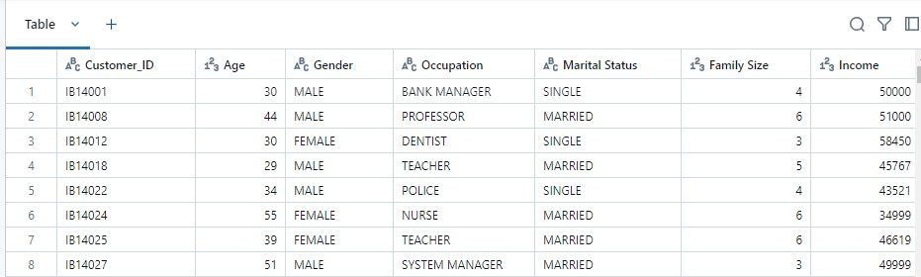

## Summary of Loading Data: -

In the first code block, I used PySpark to create a Spark session, which is essential for processing data in Databricks. I then loaded the loan data stored in a Delta format table from the Databricks File System (DBFS) into a DataFrame using spark.read.format("delta"). Delta format offers several advantages such as ACID transactions and time travel, making it a reliable choice for working with large datasets in Databricks. After loading the data, I displayed it to visually inspect the information, which allows me to quickly understand the structure of the dataset.

In the second code block, I accessed two tables from the Databricks metastore using spark.table(). This method allows me to easily query tables that have already been registered in the metastore, which is a centralized place to manage metadata for structured data. The first table, loan_table, was loaded from the default schema (hive_metastore.default), while the second table, trips_table, came from the samples.nyctaxi schema. By displaying both tables, I can examine the content and start analyzing them for insights. These two tables represent two different kinds of data: financial data in the loan_table and transportation data in the trips_table.

This entire process showcases the simplicity and flexibility of working with various data formats (like Delta) and managing data in Databricks using PySpark, which is a powerful tool for big data analysis. With this setup, I can perform various analyses, transformations, and queries on the data to derive meaningful insights.

## Practice on Delta Tables: -

1. **Loading and Displaying Data from Delta Table in Azure** spark.table("default.export")

data =spark.read.format("delta").load("dbfs:/user/hive/warehouse/export") data.show()

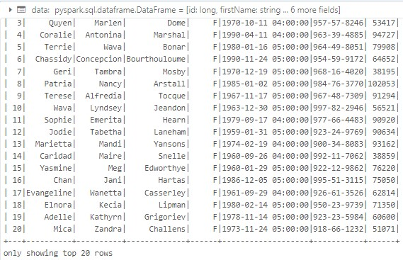

1. **Writing DataFrame to Delta Tables in Azure Databricks**

from pyspark.sql import SparkSession spark = SparkSession.builder.appName('Delta Table Write').getOrCreate() data = spark.createDataFrame([ (1, "Alice", 1000), (2, "Bob", 2000),

(3, "Charlie", 3000) ],["id", "name", "salary"])

# Write the DataFrame as Delta tables data.write.format('delta').saveAsTable("mydata_delta", mode="overwrite") data.write.format('delta').saveAsTable("mydata")

1. **Loading and Displaying Data from Delta Table in Databricks** spark.table("default.export") data = spark.read.format("delta").load("dbfs:/user/hive/warehouse/export") data.display()

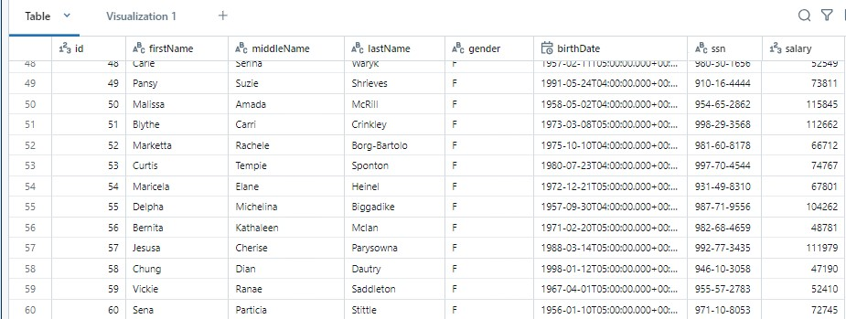

**Summary**

**on Delta Tables**

**:**

**-**

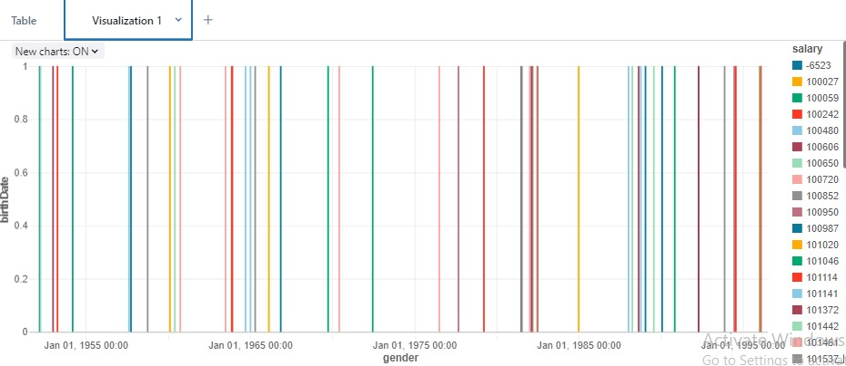

In Azure Databricks, Delta tables are used to store data in a structured format that supports efficient querying and data management. The first block of code shows how to read data from an existing Delta table stored in the Databricks metastore or from a path in the DBFS (Databricks File System). Using the spark.read.format("delta") method, we load the data from the Delta table into a DataFrame and display it. This process allows us to view the content of the Delta table, which is stored in a structured format for analysis.

Next, we see how to create and write a new Delta table from a DataFrame. The data.write.format("delta").saveAsTable("mydata") command writes the data into a new Delta table named "mydata". This code demonstrates the ability to save a DataFrame into a Delta table, making it accessible for future queries and operations. We can specify the mode (like overwrite) to control how existing data is handled when writing the new data.

Finally, the data.display() method is used to show the contents of the newly written Delta table in a Databricks notebook. Overall, Delta tables provide a powerful and efficient way to store and manage data in Databricks, with built-in support for ACID transactions, versioning, and schema enforcement. This makes them ideal for data analysis and machine learning tasks where data integrity and fast querying are crucial.

## Practice EDA Analysis: -

1. **Reading and Displaying Data from the Loan Table in Databricks**

data = spark.read.table("hive_metastore.default.loan") display(data)

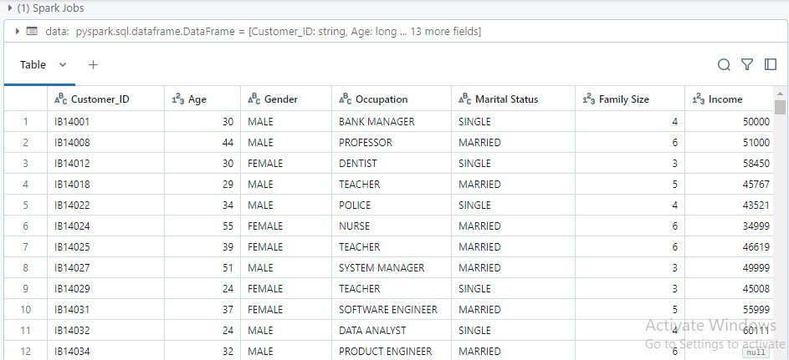

1. **Getting Row Count and Schema Information of the Data**

# Total row count data.count() # Schema information data.printSchema()

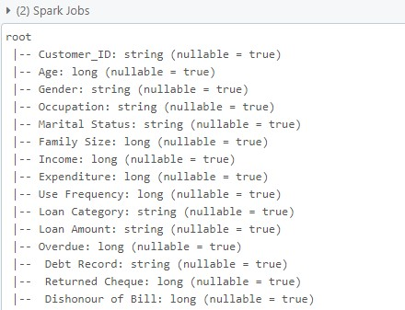

1. **Displaying Summary Statistics for 'Income' Column**

# Summary statistics for 'Income'

data.describe(['Income']).show()

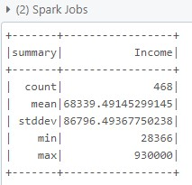

**4. Counting Rows Grouped by Gender**

data.groupBy('gender').count().show()

**5.**

**Displaying Top 5 Highest Incomes**

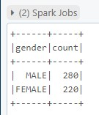

# Top 5 Highest Incomes data.orderBy(data.Income.desc()).limit(5).show()

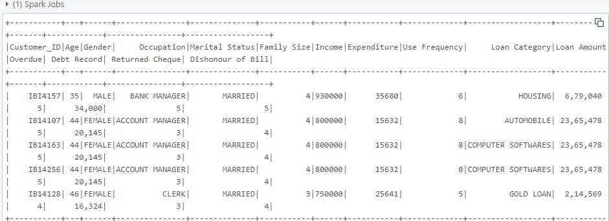

**6. Grouping Employees by Salary Buckets and Counting**

# Salary Distribution from pyspark.sql.functions import ceil, col

# Add salary buckets data_with_buckets = data.withColumn('salary_bucket', ceil(col('Income') / 20000) * 20000)

# Count employees in each bucket data_with_buckets.groupBy('salary_bucket').count().orderBy('salary_bucket').show()

**Summary of**

**EDA Analy**

**sis**

**:**

**-**

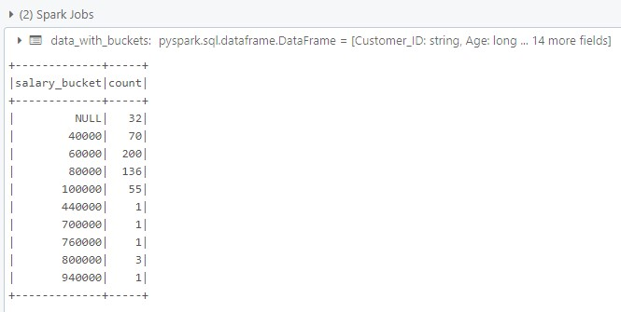

I worked on a dataset from the hive_metastore.default.loan table using PySpark in Databricks. First, I loaded the data into a Spark DataFrame and displayed it to get a view of the records. I calculated the total number of rows in the dataset with the count() function, which shows how many entries there are. Then, I examined the schema of the data to understand the structure of the table, such as the column names and data types.

I also performed summary statistics for the Income column, which gave me basic measures like the count, mean, and standard deviation. I grouped the data by gender to count how many records fall into each gender category. To further explore the data, I identified the top 5 highest incomes by sorting the data in descending order based on the Income column. Finally, I created salary buckets by dividing the Income into ranges and counted how many employees fall into each bucket, helping me understand the distribution of income within the dataset.

## Practice on Visualization: -

1. **Loading and Displaying Data from the 'loan' Table**

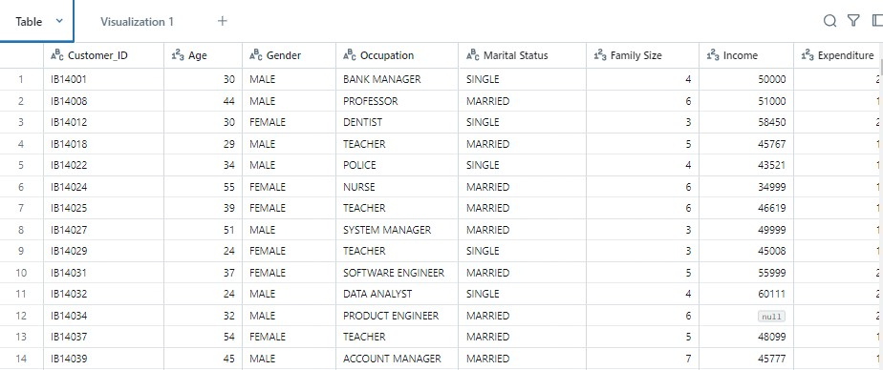

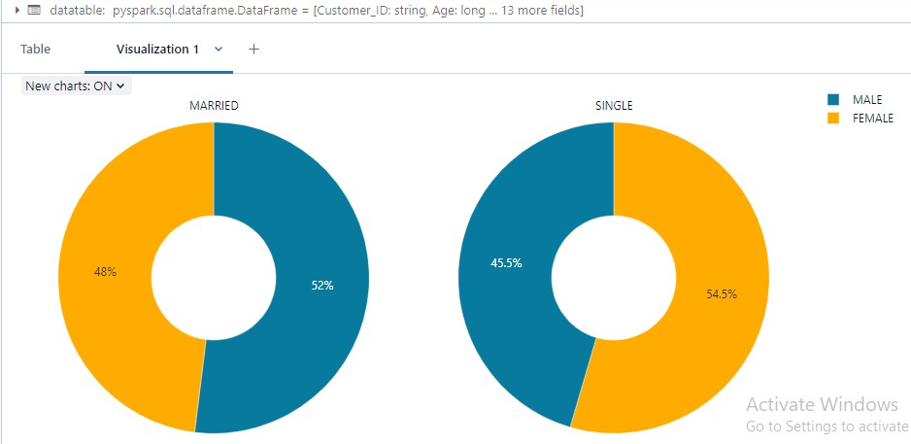

1. **Loading and Displaying Data from 'export' Table and Delta Location**

spark.table("default.export") data = spark.read.format("delta").load("dbfs:/user/hive/warehouse/export") data.display()

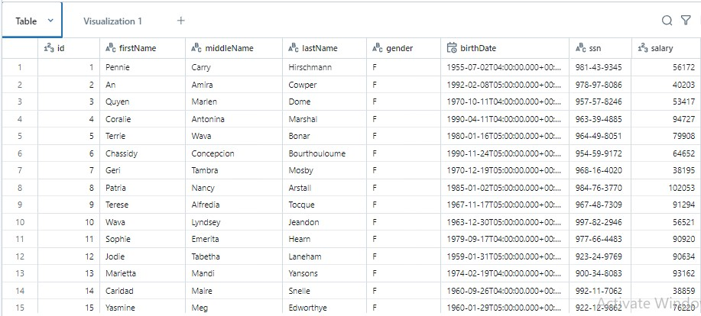

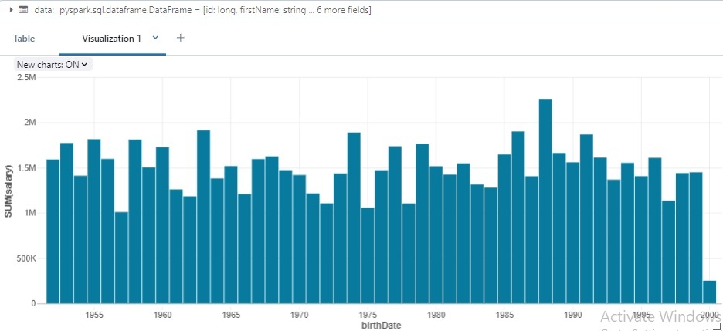

## Summary on Visualization: -

In Azure Databricks, data visualization using PySpark can help you easily interpret and present data insights. PySpark allows you to work with large datasets and perform complex transformations before visualizing the results. The display() function in Databricks provides a powerful way to visualize DataFrames directly in the notebook interface. When you load data into PySpark, whether from a table or a Delta file, you can quickly visualize it using Databricks' built-in visualization tools.

Visualizations like bar charts, line graphs, and scatter plots can be created with just a few clicks, providing an intuitive way to explore data patterns. You can create custom visualizations to examine trends over time, compare categories, or understand distributions. Databricks also supports interactive visualization, which means you can drill down into the data, filter values, and adjust axes for better clarity.

By using PySpark for data processing and Databricks for visualization, you can enhance your data exploration experience without switching tools or environments. This integration makes it easier to share insights with others and perform interactive analysis in real-time. Visualizations are crucial for communicating data findings in an understandable and impactful way.